**Generation Energy Cost Component**

* E3 ACC generation energy costs are calculated hourly for 16 climate zones.
* The average energy cost in the near term is based on the OTC Global Holdings Forwards

on-peak and off-peak market price forecasts for NP-15 and SP-15, averaged to calculate the system value. For the period after the available forward market prices, the method interpolates between the last available futures market price and the long-run energy market price. We work within the window where forecasts are available so don’t need to worry too much about the long-run energy prices for this generation component.

* Hourly shape is derived from day-ahead LMPs at load-aggregation points in northern and southern California obtained from the California ISO’s MRTU OASIS.
* The treatment of generation avoided costs updated in 2016 to reflect the recognition of carbon prices in the electricity market price forecasts. The prior ACC does not account for this. The updated methodology starts with market prices that include CO2 costs, and decomposes the market price into an energy component and a CO2 component based on the 2015 IEPR CO2 prices and the inferred market heat rates.

***OPTION 1****: We could use actual LMPs and subtract MOER* permit price.*

* *E3 MOER is calculated assuming that natural gas is the marginal fuel in all hours. The hourly emissions rate of the marginal generator is calculated based on the day-ahead market price curve and the imputed heat rate of the marginal generator*
* *We could alternatively use WattTime or HMMY to estimate CAISO MOERs.*

***OPTION 2****: Use E3 ACC energy cost component.*

* *These should be very similar to Option 1 in the years where we restrict our usage to a one year forecast horizon. But over the 2010-2015 gap these costs will diverge (note divergence in forecast natural gas prices)*

Natural gas price forecasts (nominal $/MMBtu)

|  |  |  |
| --- | --- | --- |
|  | 2010 ACC | 2016 ACC |
| 2010 | 4.89 |  |
| 2011 | 4.88 |  |
| 2012 | 5.59 |  |
| 2013 | 5.85 |  |
| 2014 | 6.06 |  |
| 2015 | 6.24 |  |
| 2016 | 6.42 | 2.19 |
| 2017 | 6.58 | 3.70 |
| 2018 | 6.75 | 3.76 |
| 2019 | 6.90 | 3.87 |
| 2020 | 7.06 | 4.06 |

**Generation Capacity Cost Component**

There are some important differences in how E3 ACC generation capacity costs are computed in 2010 versus 2016.

2011 ACC generation capacity costs (after temperature adjustments)

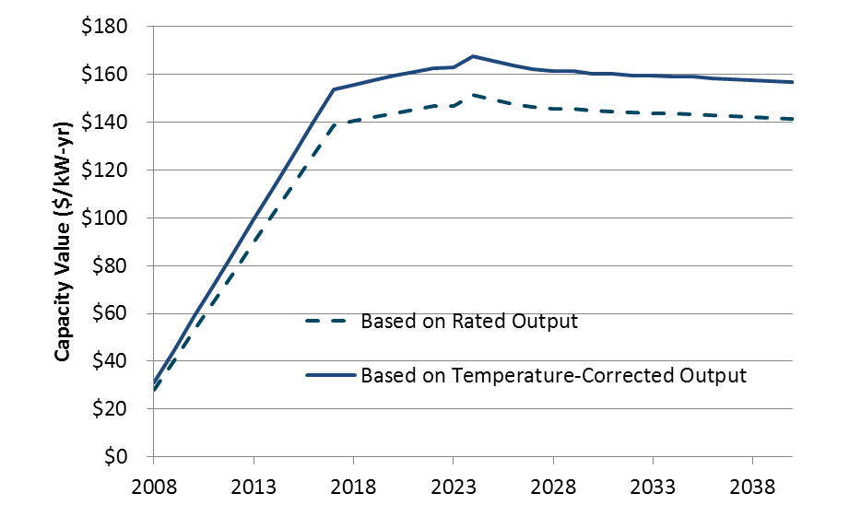

2016 ACC generation capacity costs (after temperature adjustments)



* Prior to 2016, the ACC generation capacity cost was estimated as a “near-term capacity cost”, based on Resource adequacy costs, in years prior to the “*resource balance year*” .
* The resource balance year is defined as “the year in which new forecasts predict new capacity will be needed; i.e., the year that generation resources are no longer balanced with load”.
* In the 2010 ACC, the resource balance year was defined to be 2017. The resource adequacy value was estimated at Graph suggests that the ACC model interpolates between this 2008 RA value and the residual capacity value that kicks in at the resource balance year.
* Resource balance year matters! Some stakeholders have pushed hard to adopt the practice of estimating avoided generation capacity costs by using long-term costs only (of building generation) rather than both short term costs (based on resource adequacy prices) and long-term costs. Consider this excerpt from a 2014 PUC Hearing:

*“The resource balance year approach to calculating generating capacity cost is based on a short-run market approach for the near term capacity combined with a long-term cost of new capacity beginning at the resource balance year.” SDG&E proposes that it be allowed to use a different balance year than the statewide resource balance year where “local capacity is needed in the service area before system capacity is needed.” Presumably this will translate to higher capacity prices (or higher capacity prices sooner) in that service area. Capacity cost matters because it feeds into the avoided cost of generation variable in our cost effectiveness test. The higher the capacity cost, the higher the avoided cost, and the higher the avoided cost, the more cost effective EE will appear to be.”*

In the 2014 PUC ruling:

*“We are not persuaded, however, that changing the Resource Balance Year as SDG&E requests is the best way to approximate the avoided cost of a generation project, much less of a transmission project. As discussed above, a more direct approach is to look at the avoided cost of particular projects at a busbar or transmission path affected by a locational program”*

* 2016 E3 ACC documentation refers to a “May 3, 2016 **Proposed Decision of Commissioner Florio** in R. **14-10-003** has essentially set the **Resource Balance Year** to zero, which means E3 now uses the long-run capacity cost for all years.” But I cannot find this language in the Florio decision.
* After the resource balance year, the generation capacity cost is the levelized capital cost of a new simple cycle CT unit less the margin that the CT could earn from the energy and ancillary service markets. In 2016, this calculation updated to include carbon costs in both the bid prices for the CT and the market prices for energy.
* To determine the long-run value of capacity, the avoided cost model performs an hourly dispatch of a new CT to determine energy market net revenues. The CT’s net margin is calculated assuming that the unit dispatches at full capacity in each hour that the real-time price exceeds its operating cost (the sum of fuel costs and variable O&M) plus a bid adder of 10%. In each hour that it operates, the unit earns the difference between the market price and its operating costs.
* The market revenues earned in the energy and AS markets are subtracted from the fixed and variable costs of operating a CT to determine the residual capacity value. One thing to note is that E3 natural gas price forecasts are on the high side. This will drive up wholesale price forecasts and thus reduce residual capacity value.
* The capacity value calculations are performed using both Northern California and Southern California market prices and weather information. The cost of a new CT is the same for both Northern and Southern California

As described in Chapter II and Section A of this chapter, marginal generation capacity costs (MGCC) have historically reflected the capacity cost of meeting system peak conditions. However, as intermittent renewable energy resource penetration has expanded throughout California, multiple parties have identified the need to enhance the Resource Adequacy (RA) program, or the system capacity framework, to include physical attributes for “flexible capacity.” As the electric system evolves and California progresses towards its 50% RPS requirement, the need for flexible capacity will increase and require the utilities to assess the costs directly associated with the procurement of flexible capacity.

* Notable differences in these residual capacity values ($/kW-year). These differences driven partly by differences in assumptions about natural gas/wholesale prices and partly due to differences in assumptions about new capacity costs/operations

**How to allocate these capacity costs across hours?**

* In the 2010 E3 ACC, residual capacity value is allocated across the top 250 hours of CAISO system load, in inverse proportion to the gap between the system peak load plus operating reserves and the system loads for each of the 250 hours. *Note that capacity value allocated across these 250 hours even if generation capacity constraints do not bind!*
* In this manner, the highest load hour will receive the largest allocation of capacity value on a $/kWh basis (~$2,000/MWh). The 250th hour receives an allocation of ~$400/MWh. Most of the capacity value falls in the summer on-peak period, though some falls in the summer and winter partial-peak periods as well.
* 2016 updated the approach to allocating residual capacity value uses the “RECAP” model that generates hourly, system wide expected unserved energy (EUE) values. The residual capacity values ($/kW-yr), after adjusting for temperature, losses, and planning reserve margin, are then allocated to the hours of the year with highest system capacity need using the E3 RECAP model. Documentation does note the problem that arises when all hours have 0 EUE!
* After reweighting, the result is 8760 hourly capacity allocators. As far as I can tell, no attempt to differentiate across CZs.
* GRCs take a similar weighting approach based on the likelihood that the electric system will be unable to serve customer demand in any given hour. There is always some likelihood, however small, that the system will be unable to serve demand due to insufficient availability of generation relative to the electricity demanded by customers. The risk of a generation shortage can be reduced by having more generation available than forecast peak demand (i.e., a reserve margin), but this additional generation capacity imposes costs on customers. Loss of Load Expectation (LOLE) is a measure that predicts the ability (or inability) to deliver energy to the load. An LOLE analysis can provide insight into the planning reserve margin required for each LSE in a region. The relative LOLE provides a method for allocating annualized capacity 22 value across hours in proportion to when the loss of load.

***OPTION 1****: Use E3 ACC off the shelf. Interpolate missing values (across years but within months or days?) by increasing linearly btw 2010 ACC and 2016 ACC. Because these are system-wide, we do not need to worry about the spatial dimension.*

***OPTION 2:*** *RA approach? This follows more closely the example of PG&E in the 2016 rate case:*

* In the 2016 GRC, PG&E estimated the *short-run* cost of capacity as the going-forward fixed cost of the existing generation resource net of energy gross margins it earns from the spot energy market over the period 2017-2022. They assumed an existing combined cycle gas turbine (CCGT) plant as the marginal unit. The going-forward fixed cost consists of fixed O&M, insurance and property tax. Insurance and property tax are estimated based on the capital costs.
* To calculate levelized MGCC, PG&E first calculated a Net Present Value (NPV) sum of the six years of MGCCs and then converted this NPV to a levelized value. PG&E used its after-tax Weighted Average Cost of Capital (WACC) of 7.0 percent. The estimated net costs of capacity: \$30.23/kW-year, \$29.62/kW-yr, \$28.53/kW-yr, \$27.63/kW-yr, \$27.70/kW-yr and \$27.42/kW-yr for 2017 through 2022, respectively.
* This represents the cost of an existing CCGTs fixed costs above and beyond what it could earn in the energy market. These are much closer to the resource adequacy value that E3 estimated at $28.07/kW.
* Strawman proposal: We could work with a nice round number like $30/kW which represents going forward fixed cost of a marginal generator (citing rate cases and RA numbers from E3).
* To assign this cost across hours, follow PCAF weighting scheme. The problem with the RECAP/EUE approach is that, in years where system wide expected unserved energy values are uniformly zero, there’s no way to allocate costs. So we could use the PCAF approach. Take the top k hours (in terms of load)

PCAF[h] = (Load[h] – Peak load [h]) / Sum of all positive (Load[h] – Peak[h])

**Transmission Capacity Component**

In addition to transmission congestion and line losses, which are short term costs reflected in LMP, DERs can also potentially avoid the longer-term costs of transmission capacity additions.

Those longer-term costs are substantially reflected in generation capacity prices and the congestion component of LMP, which captures what wholesale electricity purchasers are willing to pay over the short-term to overcome the transmission constraints in a particular location by buying electricity from accessible resources and routing it around the constraints. But relying on LMP can risk ignoring DERs’ potential to avoid significant long-term costs.

A more focused calculation of the avoided cost of additional transmission can be done either by estimating the relationship between planned transmission capacity additions and their associated revenue requirements, or by a more intensive modeling exercise that estimates the sensitivity of transmission capacity needs to incremental changes in load of the sort affected by the installation and operation of DERs.

Transmission avoided capacity costs represent the potential cost impacts on utility transmission investments from changes in peak load. The idea is that reductions in peak loadings could reduce the need for some transmission projects and allow for deferral or avoidance of those projects. The ability to defer or avoid transmission projects would depend on multiple factors, such as the ability to obtain sufficient dependable aggregate peak reductions in time to allow prudent deferral or avoidance of the project, as well as the location of those peak reductions in the correct areas within the system to provide the necessary reductions in network flows.

The locations of the needs for demand reductions or distributed generation or storage will move over time as loadings on the utility systems evolve differently in different areas within the utility service territories.

Peak load has not been growing in CA. So it is not entirely clear to me why we should be counting these as avoidable costs?